FALL 2021 September & October Program Descriptions

Mondays
FOOTBALL (West)
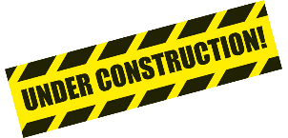
YC’s version of adapted football! Teams will practice weekly with Coach Jimmy and go head-to-head at the East vs. West YC Superbowl Showdown!

CREATIVE CONSTRUCTIONS
This hands-on program will test your imagination and ingenuity. Participants and volunteers will build inventions, take part in creative problem-solving, and explore new materials.

Tuesdays
FOOTBALL (East)
YC’s version of adapted football! Teams will practice weekly with Coach Jimmy and go head-to-head at the East vs. West YC Superbowl Showdown!

BAT & BALL SPORTS
Baseball, cricket, and so much more! If this sport has a bat and a ball, it’s fair game.

Wednesdays
MUSIC MASTERS
From musical instruments to music videos, come play a tune and dance to the beat with us!

YELP OUTDOOR SPORTS & GAMES
For ages 16-25, our YELPers will get outside, get moving, and connect with friends.

OUTDOOR EXPLORATION & SPORTS
Explore one of Ohio’s beautiful Metroparks and play some truly adventurous activities!

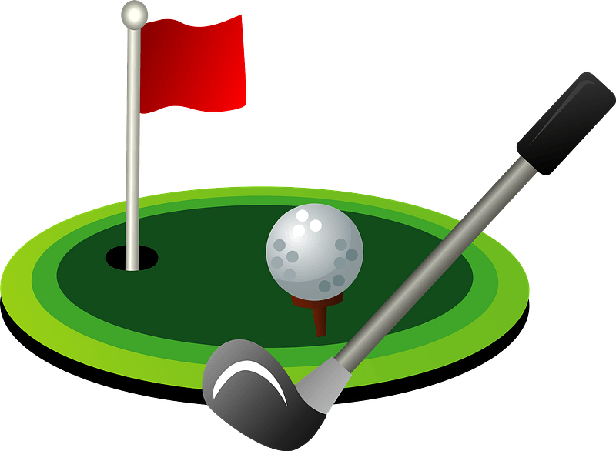
Thursdays
GOLF
Learn to play golf at the North Olmsted Golf Course with Trevor from The Turn!

GOOFY GAMES
Whether it’s a twist on a classic sport or a totally made-up competition, these games are sure to make you giggle!

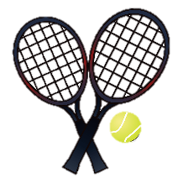
RACQUET UP
Badminton, tennis, and even pickle ball! Grab a racket and learn some new sports!

HANDCYCLING & ARCHERY
Join us for two of YC’s favorite outdoor activities. Whether you’re a first-timer or a veteran, these sports are unique and exciting!

Fridays
SOCCER (East & West)
Join Coach Chris and Coach Abbie on Fridays in September and October to practice your soccer skills. East and West teams will join forces to battle against our rival, Empower Sports, in a soccer match at the end of the season.

HALLOWEEN PARTY
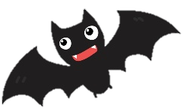
One of YC’s most popular programs returns in all its gory glory! Spend a spooktacular evening with the YC Gang for some Halloween games, tricks, treats, and a haunted house!

Weekend and Special Events
PEDAL WITH PETE*
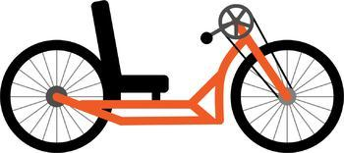
Bike or handcycle with YC to help our friends at the Pedal with Pete Foundation raise funds for cerebral palsy research! Routes of varying lengths will follow the bike paths and parkways of the Cleveland Metro Parks Emerald Necklace chain of parks to the west and south of Cleveland.

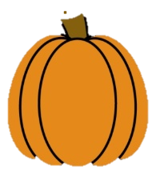
KRAZY KAMP FALL BALL
For ages 4-10, have a ball and celebrate the beginning of fall! Participants and volunteers will enjoy the coziest activities that autumn has to offer!

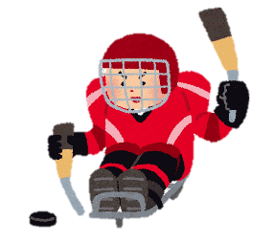
YC SUPERBOWL SHOWDOWN
This crosstown showdown is sure to be super! Join us at YC to cheer on your favorite team and see some adaptive football in action!

SLED HOCKEY ICE BREAKER*
Come play the COOLEST sport in the world with our friends on the Shaker Heights Hockey Team!
SOCCER GAME
After weeks of practice, our YC soccer teams’ efforts culminate in a battle of the century against Empower Sports!

